**User Guide for Business Account**

**Introduction**

This is a user guide for the Business Account Menu. It will set out for the user all the various options available and make clear the correct and incorrect procedures for using this program.

**Business Account Program**

This program consists of ten options, each of these have a different functions as described below;

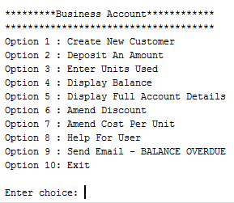

**New Customer**

A new customer must be created using option 1 before options 2-7 can be used.

If options 2-7 are chosen before new customer is created (option 1), this error message will be displayed;

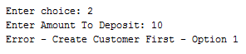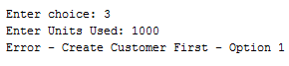









**Option 1**

**IMPORTANT** - *This option must be chosen first in order that values will be inputted into the new account so that the other options 2-7 can be used.*

**Enter Customer Reference Number**

***Chose option 1*** and enter the account number for example **‘23900’** then press enter. The program will confirm the Customer Reference Number as, **‘23900’**. This will enter the account number for future reference.

**Valid entry:**



**Enter Customer Name**

The next step is to Enter Customer Name for example, **‘Niall Curley’, and press enter.** The program will confirm the Customer Name, **‘Niall Curley’**. This will enter the customer name for future reference.

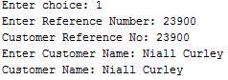

**Enter Customer Address**

Next step is to Enter Customer Address for example, **‘33 Dunmore Street’**, then press enter. The program will confirm the Customer Address, ’**33 Dunmore Street’**.

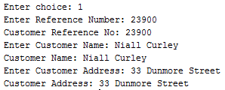

After this the program will move on to the next step, ‘**Enter Units Used’.**

**Enter Email Address**

Next step is to enter the customer email address, e.g ‘johnhart@live.co.uk’, then press enter,



**Enter Units Used**

The next step is to enter the units used by the customer. This allows for the initial recording of any units used by the customer when transferring their account, enter the units used for example **‘5478’, then press enter.** The units used are then confirmed, **‘Current Units Used: 5478.0’.** The units used are then used to calculate the balance outstanding by the customer.

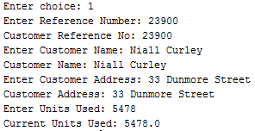

**Enter Discount**

Next step is to **Enter Discount,** this is the rate given to a business account holder, for example, **‘10%’ and press enter.**

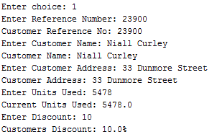

**Complete Entry of Business Account Holder**

This is what the completed option 1 should look like;



**Invalid entries**

In the case of an invalid entry into any of the requests for user input.

For example,

If invalid input is entered for **Enter Reference Number** e.g, **‘dfh’,** letters instead of numeric values,

This will generate an, ‘**Error in input – try again’**.



The user will be given the option to try again until the right type of input is chosen, example;



**Example** of an invalid entry into, ‘**Enter Units Used: pdss’.** Input should be in real number e.g**, ‘2367.0’.** The program produces an, **‘Error in input’** with an option to, **‘try again!’**

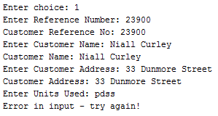

When entered correctly;

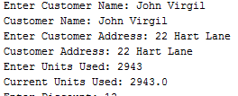

Wrong entry into discount, **‘fkm’,** and **Error** with option to **try again.** The correct entry being in numeric values.



**Deposit an Amount**

Option 2 - allows the user to deposit an amount off the balance of the business account, *this will reduce the balance each time.* The user is given the option to, **‘Enter Amount To Deposit’.**

For example, **‘20.0’.**



For example, **’10.0.**



**Deposit Amount (Invalid Entry)**

If a wrong entry is made into, **Enter Amount to Deposit**, e.g, ‘**fdf’.** An error will be displayed requesting the correct entry of a numeric value or the option to create a new customer first.

**Important** - *Before an amount can be deposited, a new customer must be created first as there is no balance to be reduced.*



**Enter Units Used**

When option 3 is chosen, ‘**Enter Units Used’**, this allows the user to enter how many gas units that the customer has used in the most recent inspection. **This will increase the balance.**

**Example;**

Customer details with current balance:

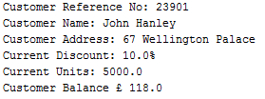

When 1000.0 units are added:

**Invalid Entry**

If an invalid entry is made for example, **‘fgt’**, instead of a numeric value. This error message will appear:



**Display Balance**

Option 4 – allows for the display of the current balance of the business account if a new account has been created with option 1 first. Choose option 4 then press enter. The balance will be displayed.

**Example;**



**Invalid Balance**

If option 4 is chosen before a new customer is created then this error will be displayed;



**Display Full Account Details**

Option 5 – display full account details allows for all the details of the business account holder to be displayed. Chose option 5 and press enter.

**For example**;

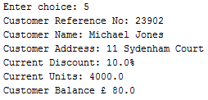

**Invalid Entry**

If option 5 is chosen without a new customer being created then this error will be displayed.



**Amend Discount**

Option 6 – Amend Discount this allows the user to change the discount that has been given to the business account. This new rate will be used to calculate the reduced amount given to the business account.

Chose option 6 and enter new rate. The new rate will be displayed.

**Example;**



**Invalid Amend Discount**

If an incorrect entry is chosen either option 6 is chosen before a new customer is created or an invalid input for new discount for example, ‘**flpp’**, *letters instead of numeric* - this error will appear.

New Customer not created first;



Wrong entry ‘**flpp’**.



**Amend Cost Per Unit**

Option 7 – amend cost per unit allows the user to change the cost of each individual gas unit. This will be calculated with the with number of unit used when calculating the balance owed by the business account customer.

Chose option 7 and then enter new cost per unit and press enter.

**For example;**



**Invalid Amend Cost Per Unit**

If an incorrect entry is made, either option 7 is chosen before a new customer is created or an invalid input for new discount for example, ‘**zzff’**, *letters instead of numeric* - this error will appear with instructions.

New Customer has not been created first;



Wrong Entry;



**Help for User**

Option 8 - This is short guide that will facilitate the use of the menu program. It contains step by step guidance with valid and invalid entries and right outputs that should be displayed. Chose which option required and follow instructions.

Enter choice 8 & press Enter;

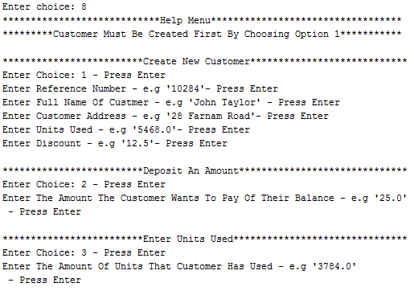

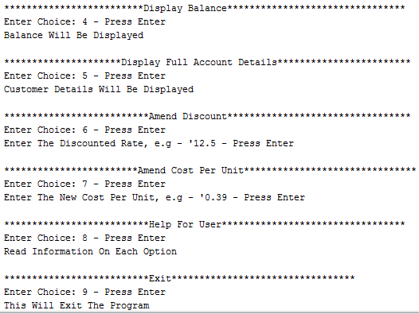

**Send Email BALANCE OVERDUE**

Option 9- this allow the user to open and email on outlook express and send the overdue account message.

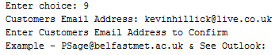

The user must confirm the Business Customers Email address and press Enter. Outlook Express will then appear at the bottom of the screen, click on this and press ‘Send’ at top right hand corner.

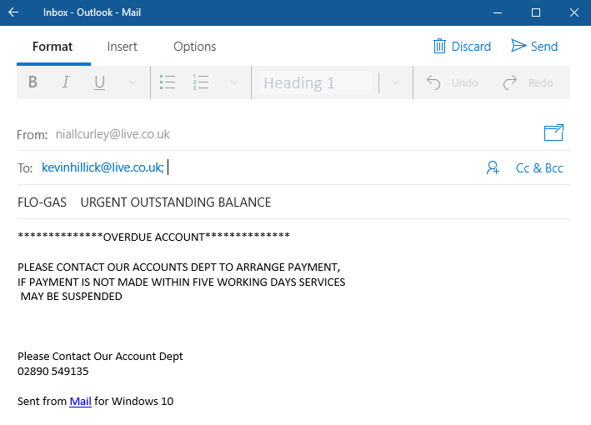

The customer will receive the email for outstanding balance with relevant contact number.

**Exit**

Option 10 – this allows the user to close the program and exit.

